Java Project 2017 Submission

STAND-OFF

By Jack Teahan t00192059

<https://github.com/JackTeahan98/OOP-Assign-2017/commits/master> - GitHub Link

**Stand-Off:**

This projecty is a game in which two players must shoot bullets across at each other while avoiding them and the electric perimeters at the same time. First player to lose all his lives loses, or if he touches the electric he also loses, which promtps a suitable screen for the winner. The number of wins and games played is added and saved to a file.

**Coding The Game and its Graphics:**

A good portion of the game was tough but very doable to code, and some portions where you would expect advanced code, (ie moving images/objects is pretty straight forward, by just setting new x or Y positions from the old position)

The most difficult parts of the code was the threading, as we never covered this topic before, and the bullets to fire.

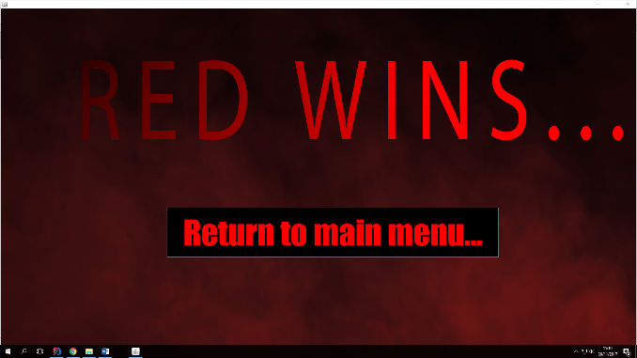

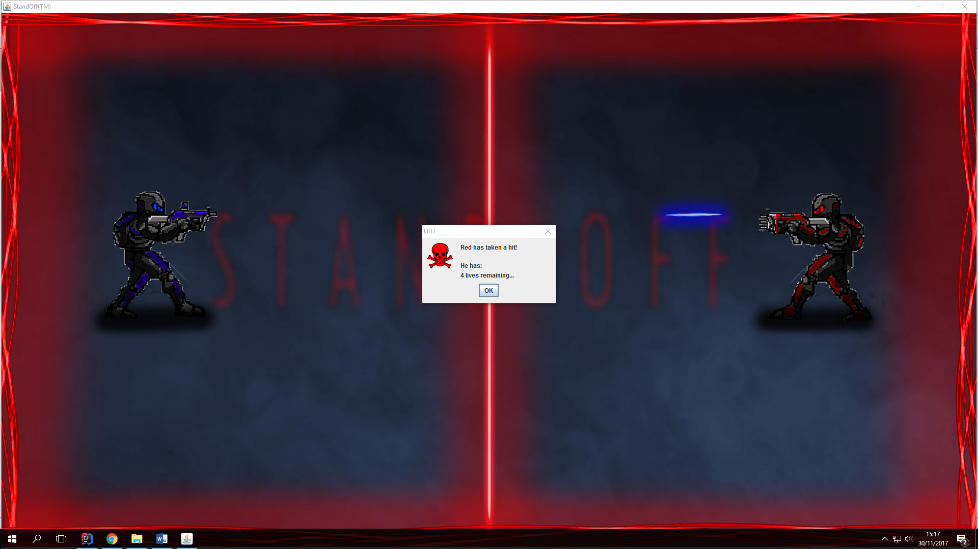

Threading:

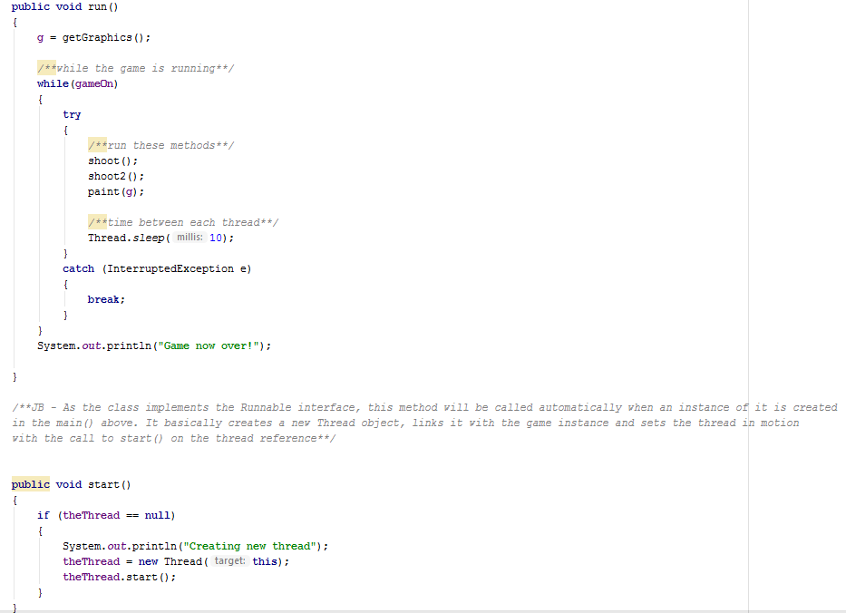

Shooting:

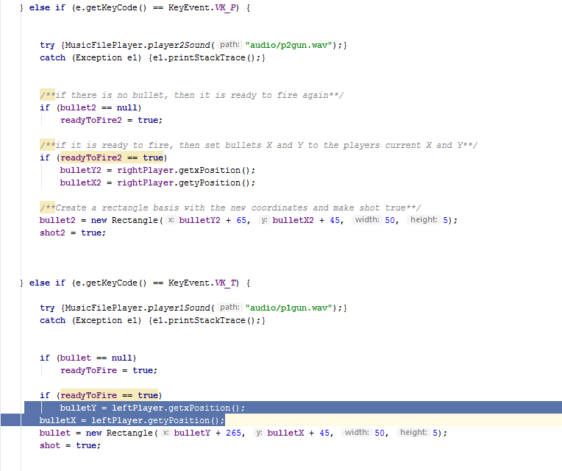

The bullet was completed by simply adding along its x axis every refresh from the thread and having booleans to teremin if it was shot, or if it is currently ready to fire, depending on its position and status

The thread, although Still abit of an unknown in soome parts, basically calls methods, in this case the shooting methods, sleeps for 40 milliseconds or so, then repaints again and continues on

There was a total of 4 classes in my projects

* Player: this class set up all the attributes of each player, name, x position, y position and image
* StandOff(Main) This ran the main menu GUI, all its relevant buttons and listeners and connected to the GooEee class
* GooEee: This class holds all the different methods that run the game, it instanciates the 2 players and calls the sound methods
* MusicFilePlayer: This class contains different methods which represent different sounds in the game, the meethods are then simply called for the sound to work

**UML/VOPC**

